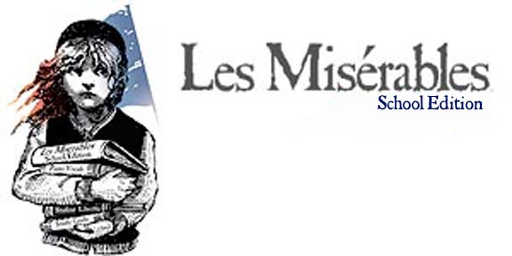

Join us for the first Oregon performances of Les Misérables:School Edition, a new version of the beloved musical sensation, containing all the characters, songs, and epic drama of the original. Don’t miss this spectacular and unique musical theatre event!

NOVEMBER 1, 2, 5, 7, 8 ,9, 12, 14, 15, 16
Hood River Valley High Bowe Theatre
Curtain 7:30 p.m.
Adults $7 Students/Children under 12 $5
Special rates available for parties and groups.
Tickets at the door and in advance at
Waucoma Books, Hood River

Call 541.386.4500 for information or visit us on the web:
W3.gorge.net/mdstg/LesMiz.htm

Join us for the first Oregon performances of Les Misérables:School Edition, a new version of the beloved musical sensation, containing all the characters, songs, and epic drama of the original. Don’t miss this spectacular and unique musical theatre event!

NOVEMBER 1, 2, 5, 7, 8, 9, 12, 14, 15, 16
Hood River Valley High Bowe Theatre
Curtain 7:30 p.m.
Adults $7 Students/Children under 12 $5
Special rates available for parties and groups.
Tickets at the door and in advance at
Waucoma Books, Hood River

Call 541.386.4500 for information or visit us on the web:
W3.gorge.net/mdstg/LesMiz.htm

